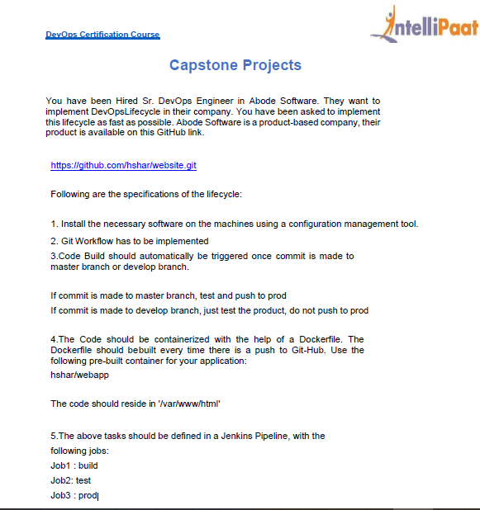

* First we need to get three instances one is master and other two are slaves for testing and production.

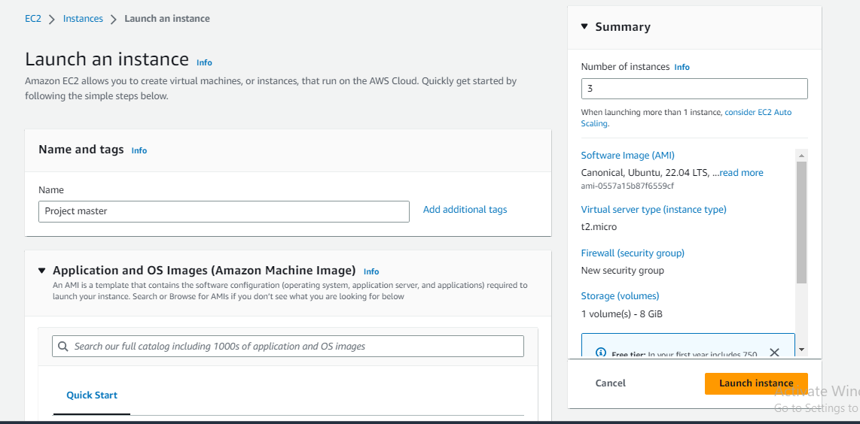

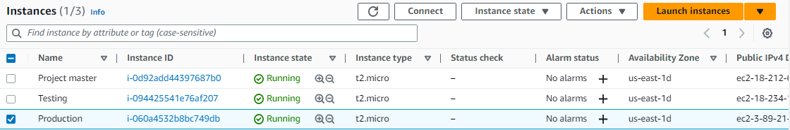

* Connect to the instances and updating them

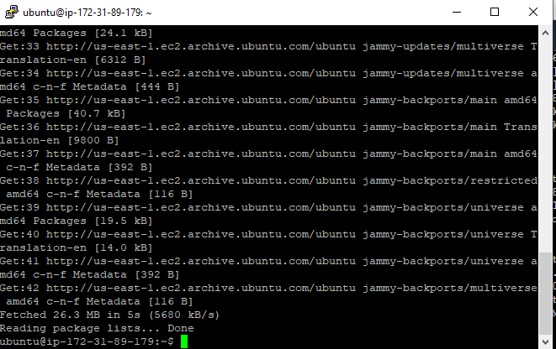

* Now install ansible on the master using
* “sudo apt install software-properties –common”
* “sudo add-apt –repository –yes –update ppa:ansible/ansible”
* “sudo apt install ansible”

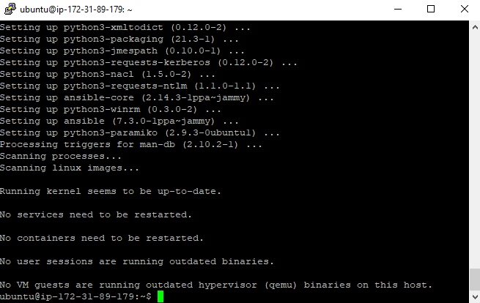

* Now creating configuration files for ansible to configure the master and slaves
* So we need to first create a key pair to connect the systems to the master.

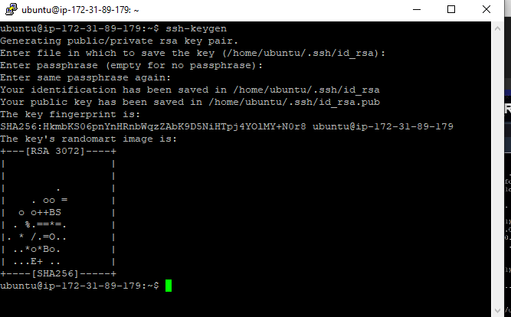

* Navigate to the public key and copy it and paste it in the slave machines.

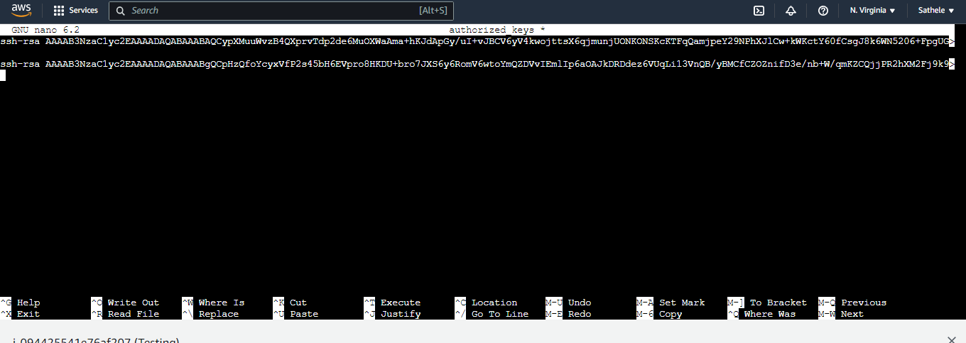

* Try to connect the instance

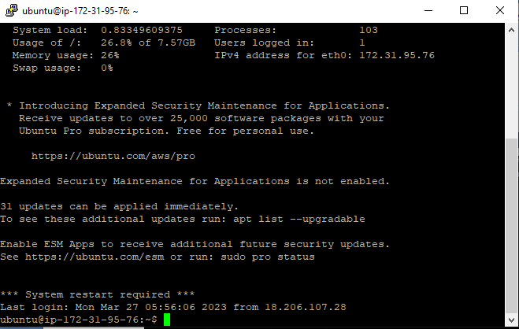

* Navigate to the host file of the ansible and record the test and production private IP there

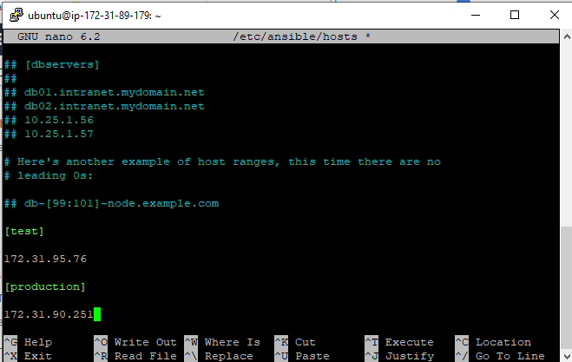

* Try to ping the slaves from the master

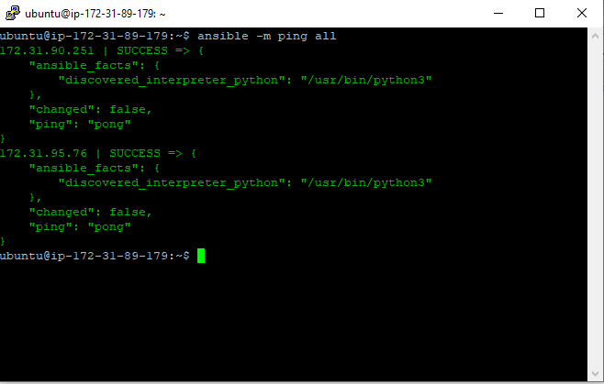

* Now we need to configure the servers using ansible playbooks
* Create playbook

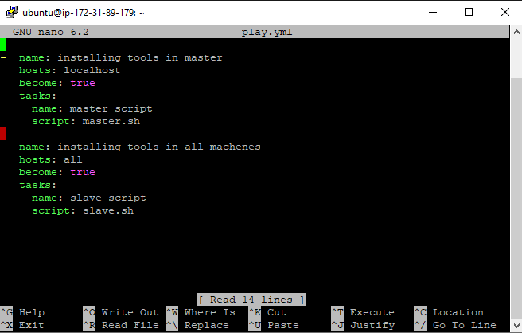

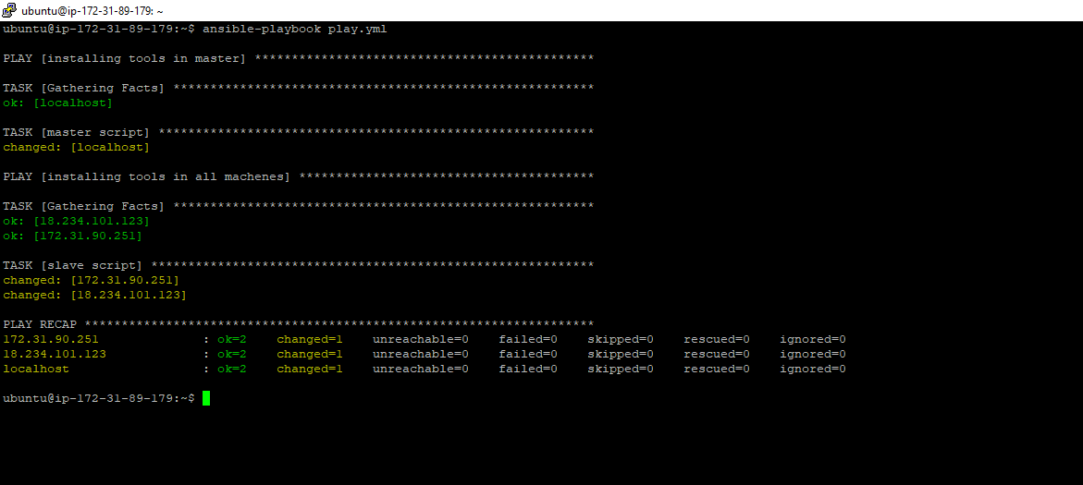

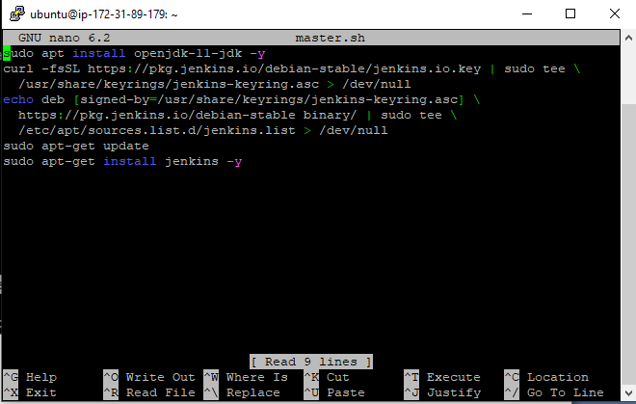

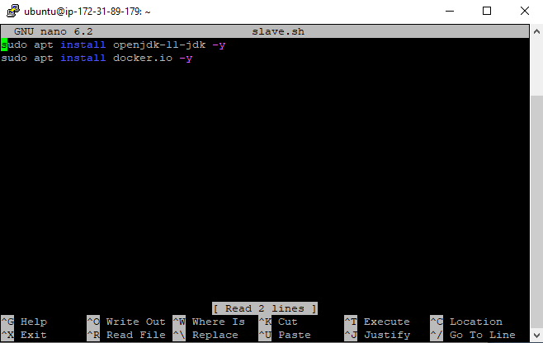

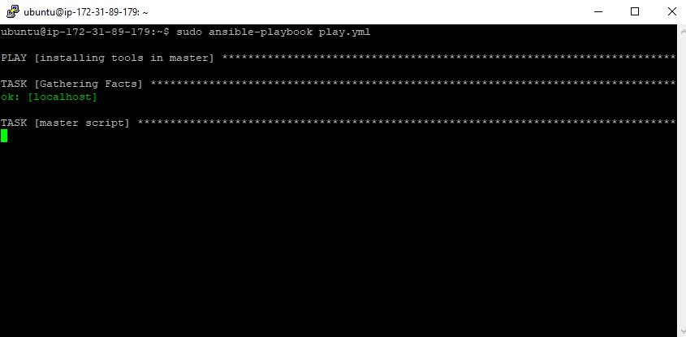

* Let us try to access master

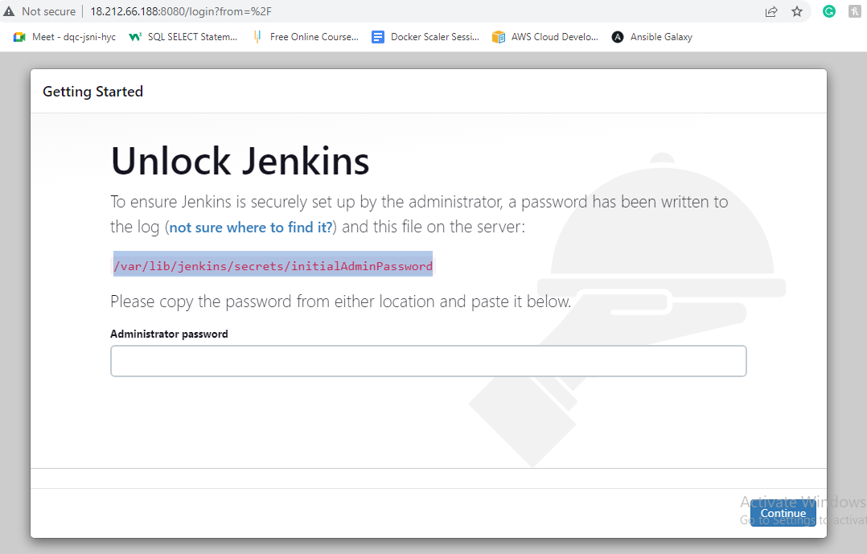

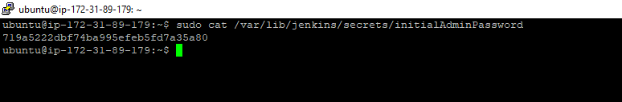

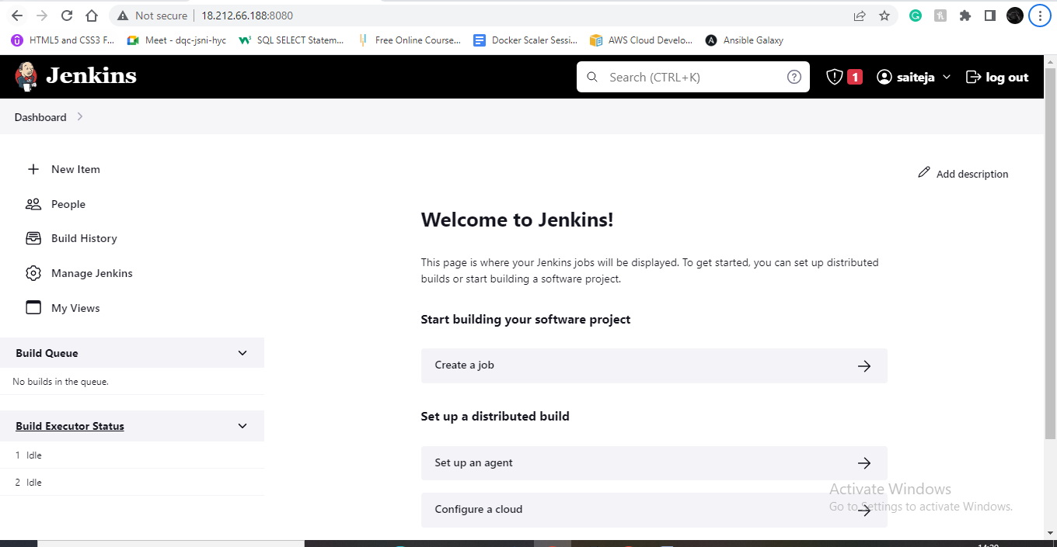

* Now we add the nodes that is the slave servers
* Go to manage Jenkins and there add nodes

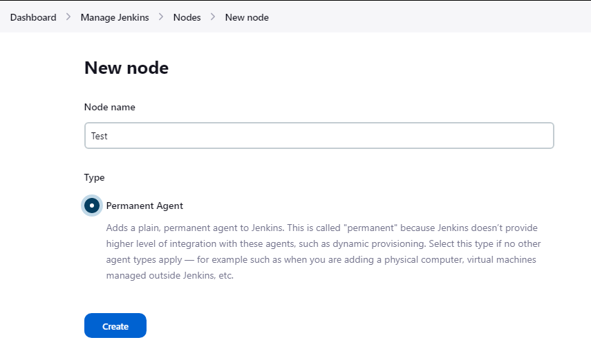

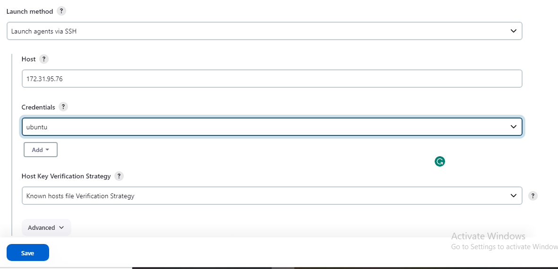

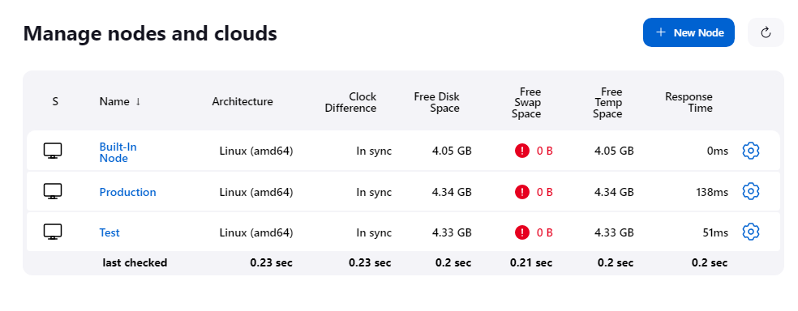

* I have added two nodes giving the host name as private IP of respective services
* Now let us clone the github repository in the master

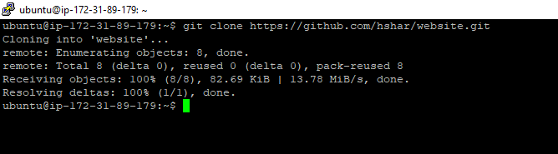

* In the cloned repository we need to create a Docker file

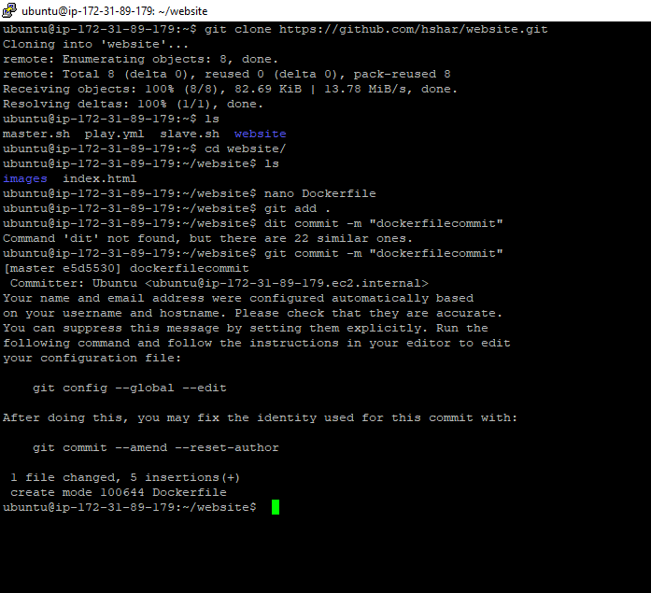

* Creating a develop branch

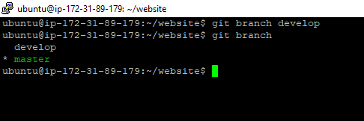

* Push the repo to the git hub

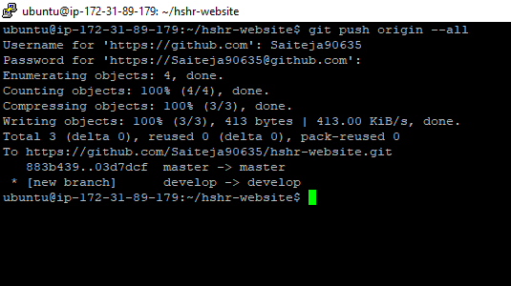

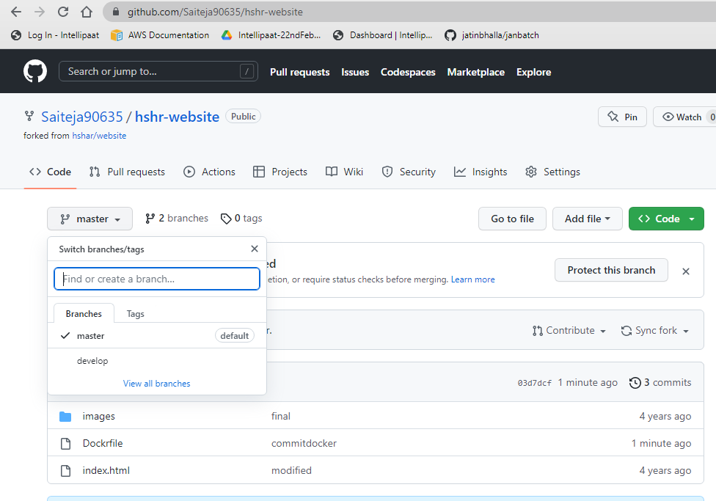

* Now we can go for jon creation

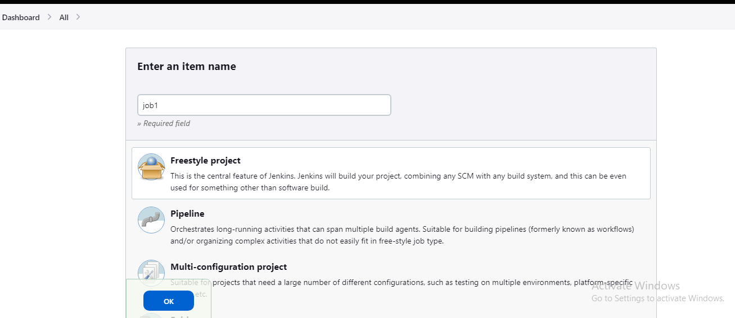

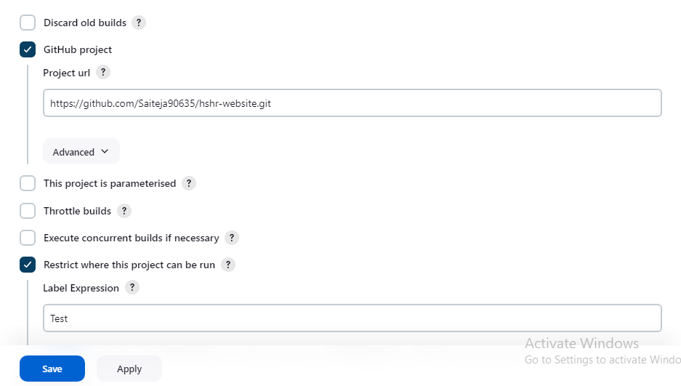

* The branch we associate or restrict it is Develop
* Create a Git hub webhooks
* Similarly we create the remaining jobs

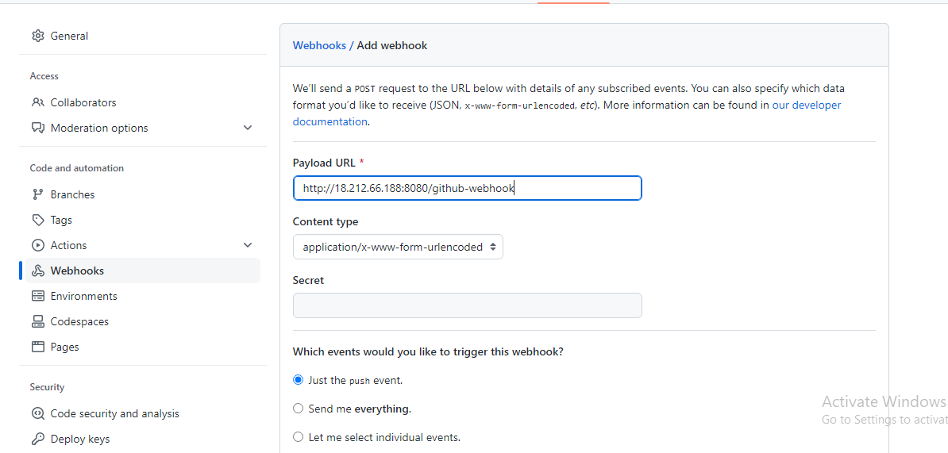

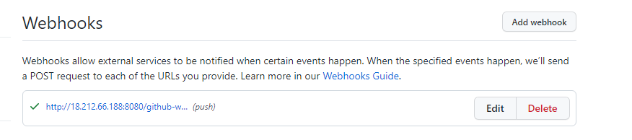

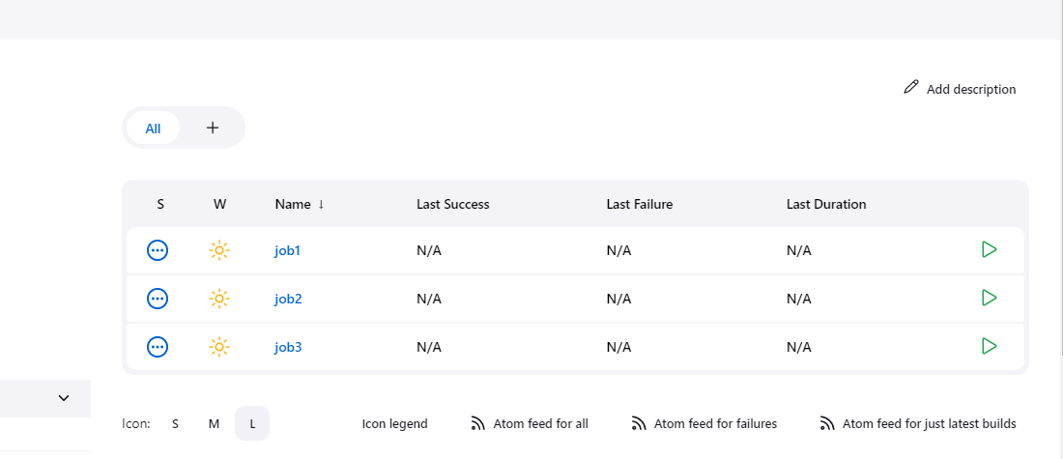

* Now let us configure all the jobs
* We need to run the Dockerfile

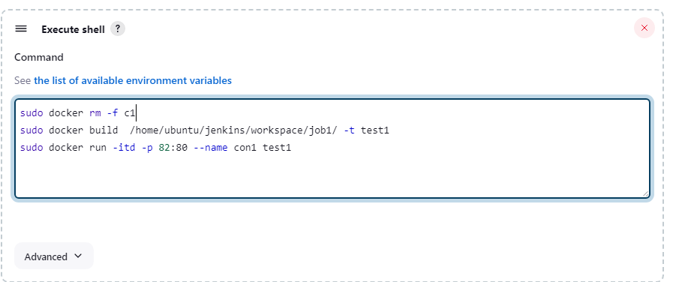

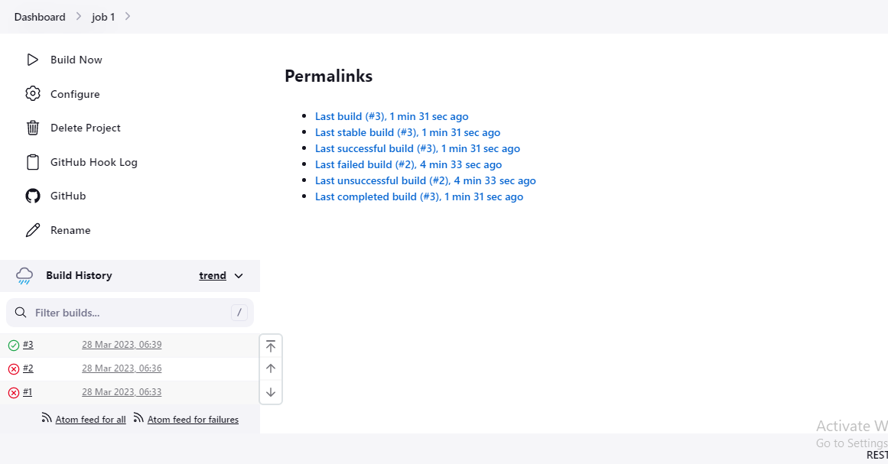

* And when we try to check the ip address of testing server at port 82 we should get

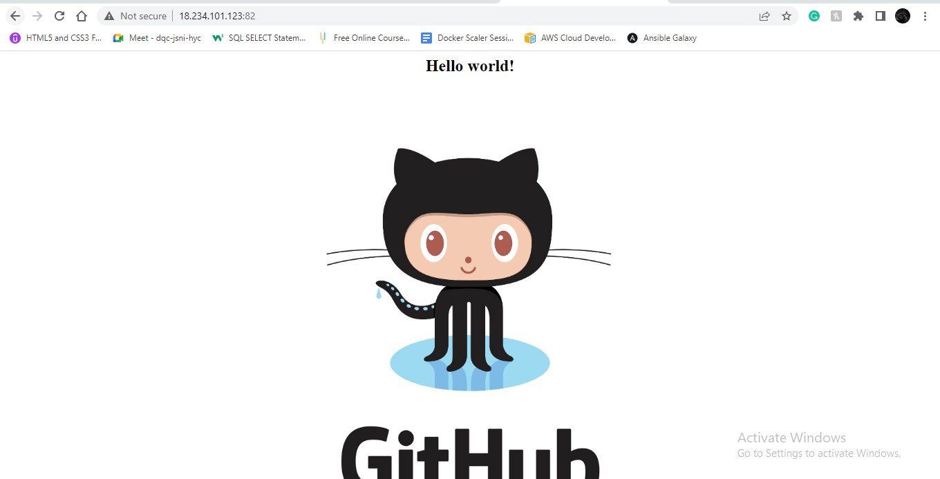

* Copy the same commands but change the port number, container name

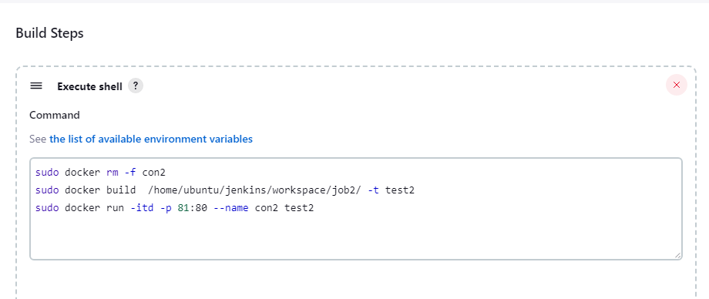

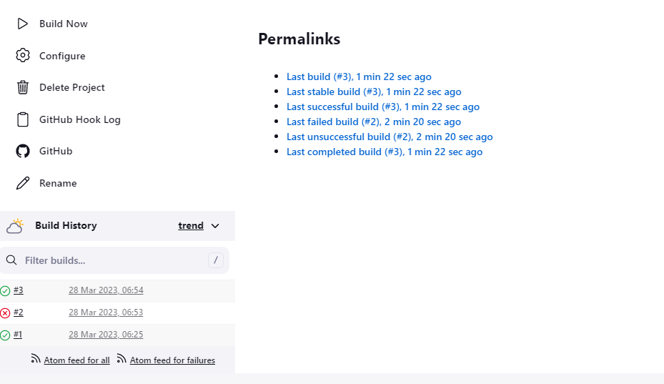

* Do the same with job3

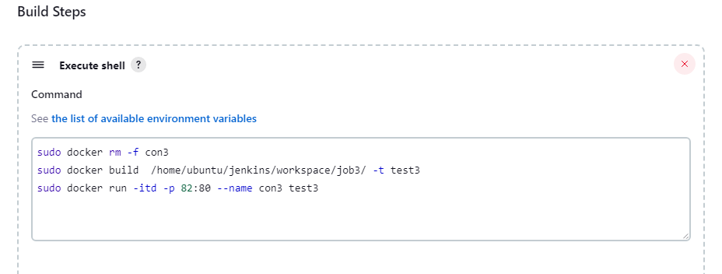

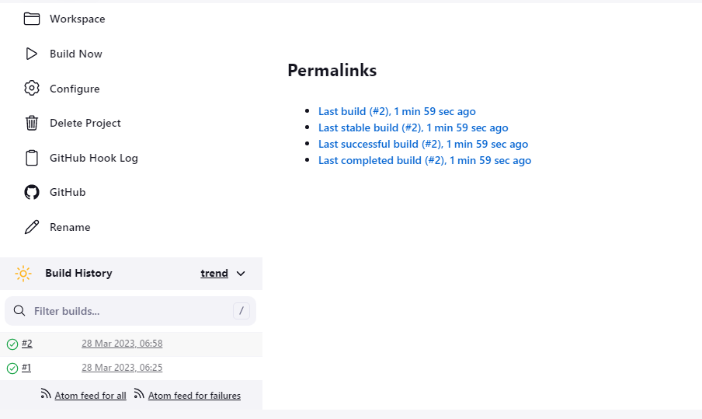

* Now according to the assignment once the master branch got a push in testing server it should further pusher to prod
* So let us create a post build action for job2 which says “job3 should build only after the succefull build of job2”

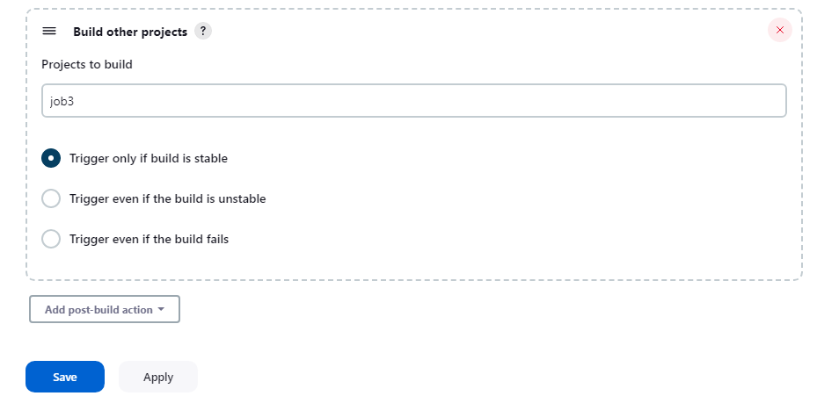

And thus we have completed all the steps

